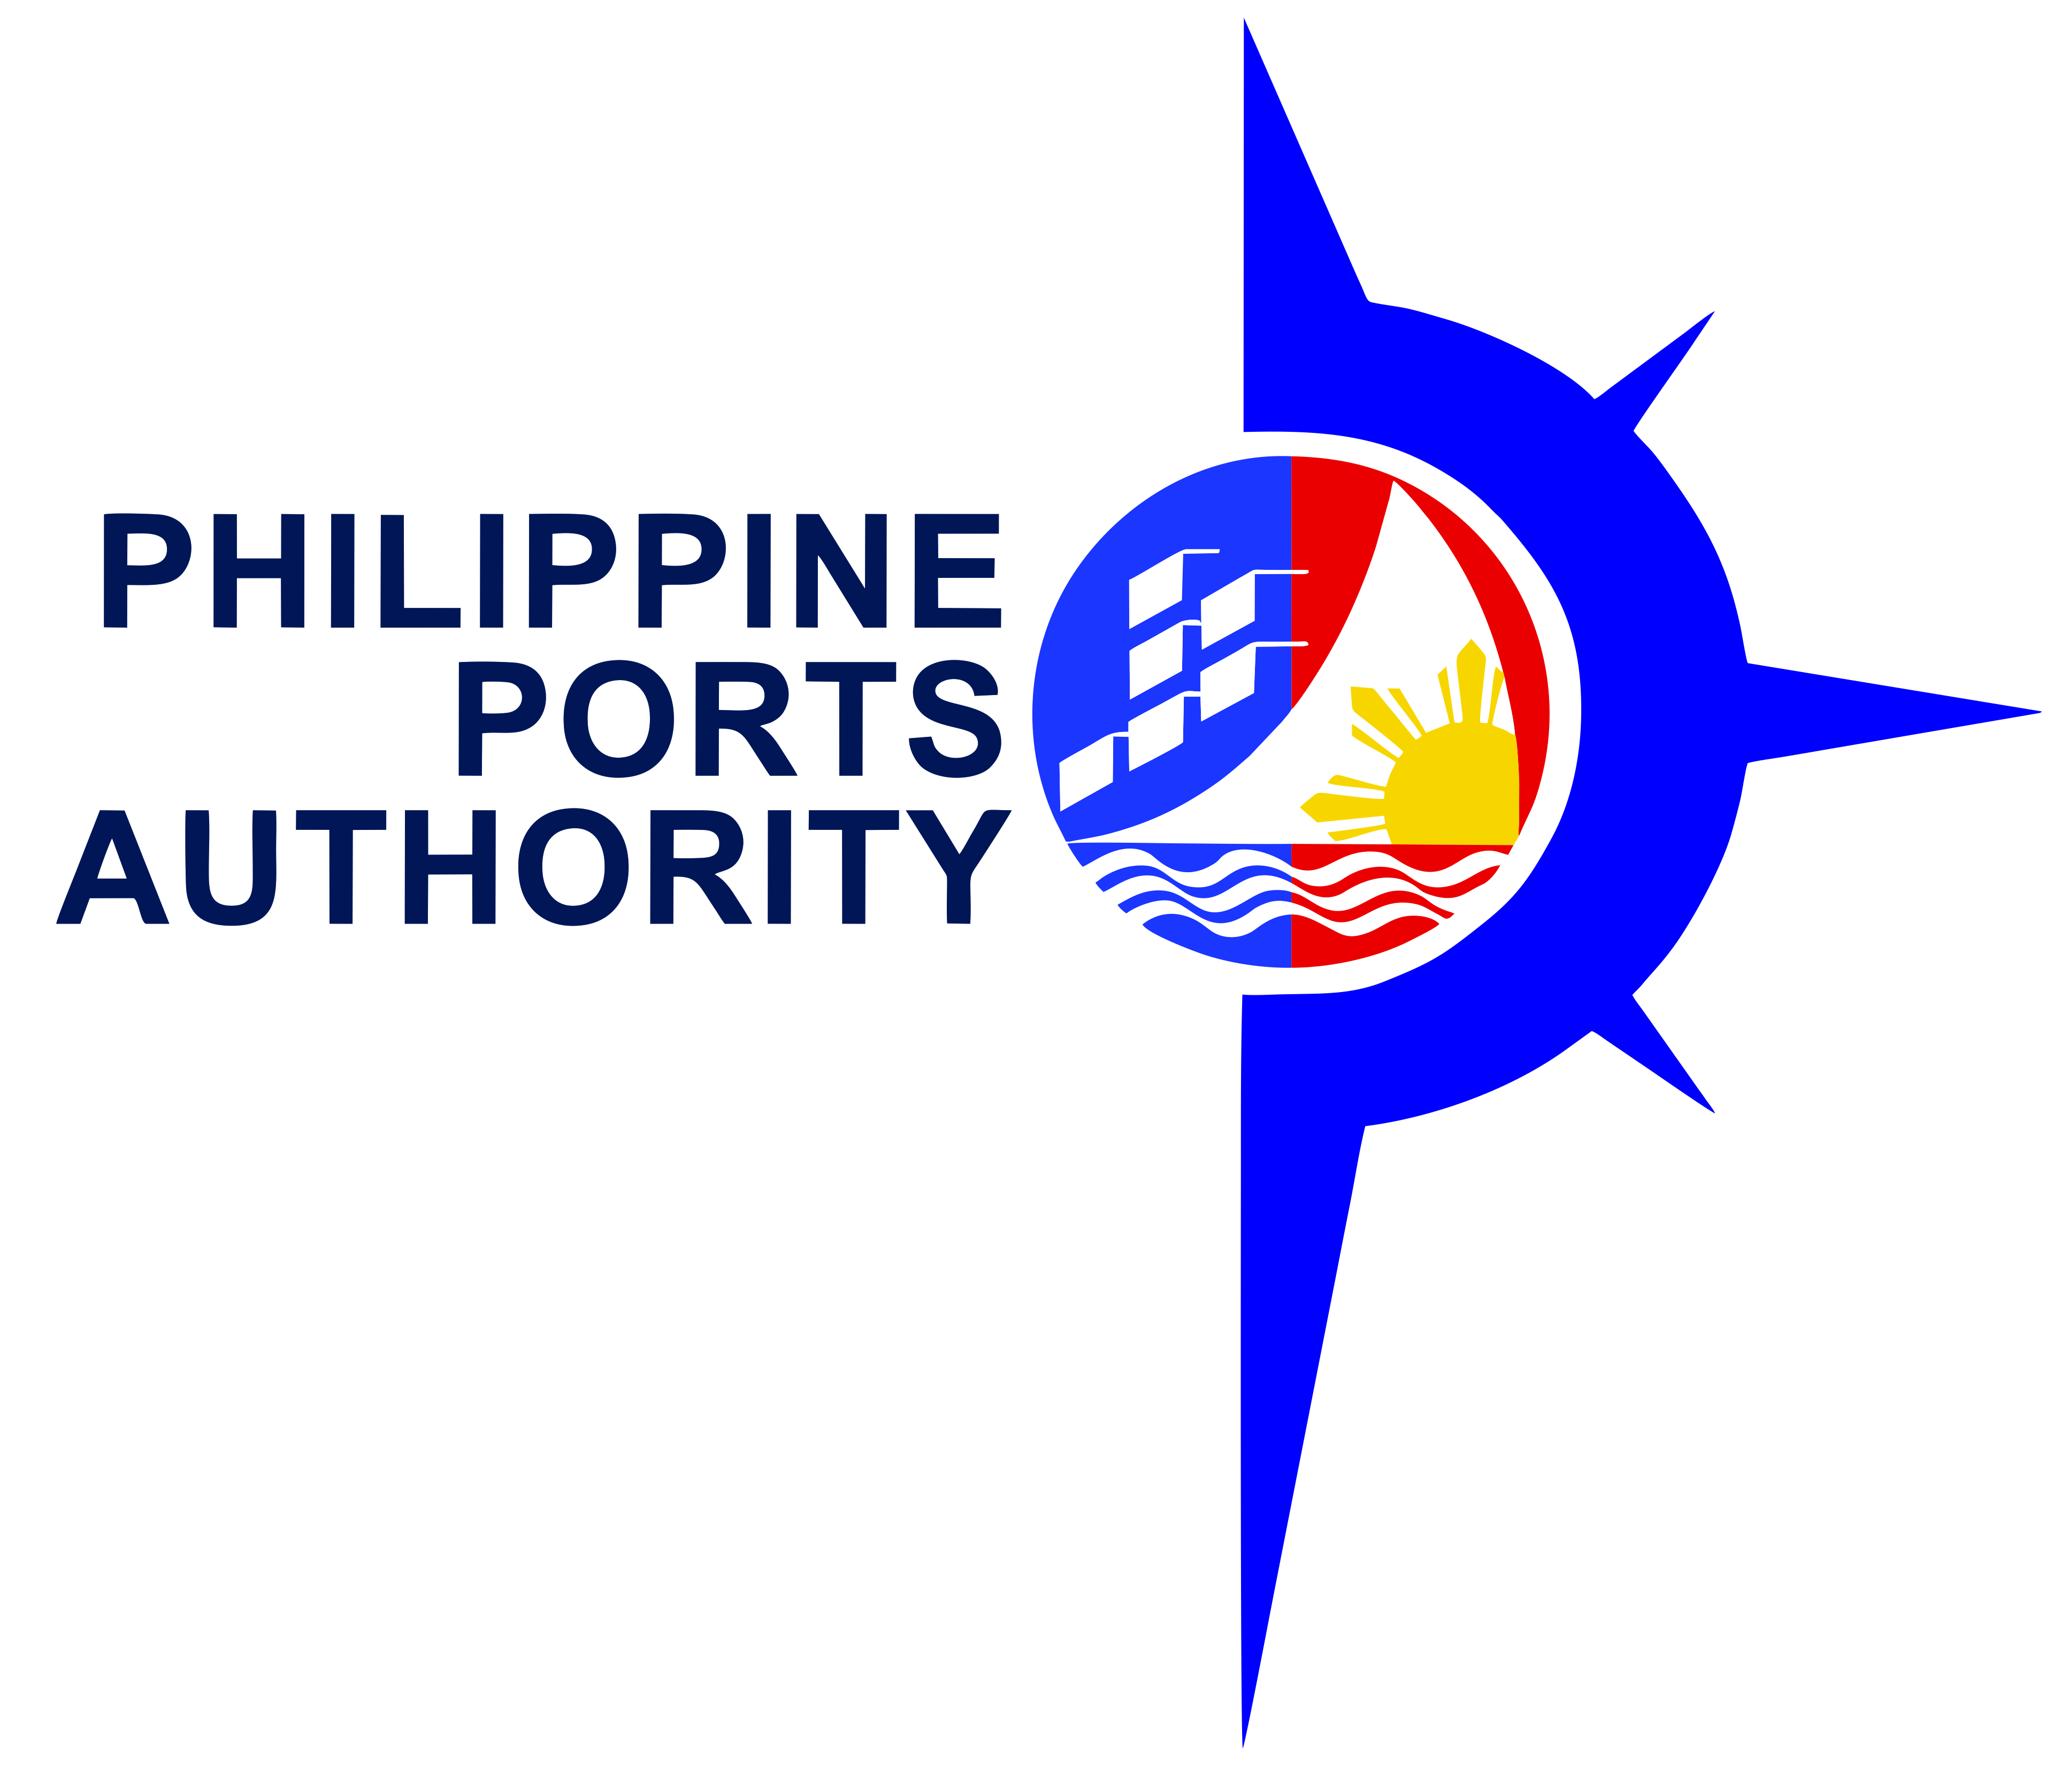

REQUEST FOR QUOTATION (RFQ)

The Philippine Ports Authority, PMO- Zamboanga del Norte, through its Bids and Awards Committee will undertake a Small Value Procurement for the SUPPLY OF LABOR, TOOLS, MATERIALS, AND EQUIPMENT for the conduct of Repair of Damaged RC Curb along RC Pier, Port of Dapitan, Dapitan City, Zamboanga del Norte, in accordance with Section 53.9 of the Implementing Rules and Regulations of Republic Act No. 9184.

Name of Project : SUPPLY OF LABOR, TOOLS, MATERIALS, AND EQUIPMENT for the
conduct of Repair of Damaged RC Curb along RC Pier, Port
of Dapitan, Dapitan City, Zamboanga del Norte.

Approved Budget : One Hundred Twenty-Six Thousand Six Hundred Ten pesos and 68/100
For the Contract (P126,610.68)

Specifications : See attached Scope of Work

Location : Port of Dapitan, Dapitan City, Zamboanga del Norte

Contract Duration/ : For a period of six (6) calendar days

Interested bidders are required to submit their valid and current Mayor’ Permit, Income/Business Tax Return, PHILGEPS Registration Number, PCAB License & Omnibus Sworn Statement upon submission of quotation. Bids received in excess of the ABC shall be automatically rejected at Bid Opening.

A complete set of Bidding Documents may be purchased by interested bidders from the address below and upon payment of a non-refundable fee for the Bidding Documents in the amount of Five Hundred Pesos (Php 500.00), exclusive of VAT.

Sealed Bids/Canvass from eligible bidders will be opened and a contract will only be awarded to the Lowest Calculated Responsive Bidder who was determined as such during post-qualification.

Opening of Bids/Canvass shall be on November 15, 2018 10:00 AM at the PPA Conference Room, PMO-Zamboanga del Norte, Port Area, Dapitan City.

The PPA, PMO-Zamboanga del Norte reserves the right to accept or reject any bid, to annul the bidding process, and to reject all bids at any time prior to contract award, without thereby incurring any liability to the affected bidder or bidders.

BYRON P. PATAG
BAC Chairperson PMO-Zamboanga del Norte
PPA, PMO-Zamboanga del Norte, Port Area, Dapitan City 7101

For further inquiries:
Tel No. (065) 213-6595, (065) 213-6946
Email Address:ppa.pmo.dapitan@gmail.com

Date of Publication: November 12, 2018 - November 15, 2018
PPA Website: www.ppa.com.ph
PhilGeps Website: www.philgeps.net

