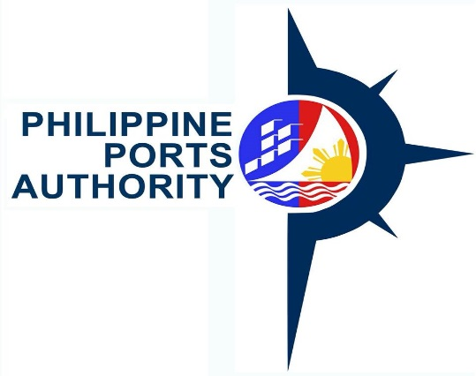

REQUEST FOR QUOTATION
(SMALL VALUE PROCUREMENT)

The Philippine Ports Authority, PMO-NOBBB, through its Bids and Awards Committee for the Procurement of Goods will undertake an alternative method of procurement through Shopping for the Supply, Delivery of Four (4) Units of Public Address System, in accordance with Section 52.1 (b) of the Revised Implementing Rules and Regulation of RA 9184.

Name of Project : Supply, Delivery of Four (4) Units
of Public Address System at the following
responsibility centers of PMO-NOBBB:
- TMO – San Carlos
- TMO-Danao
- TMO-Pulupandan
- Baseport – Banago

Approved Budget for the : Php 200,000.00
Contract

Deadline for Submission of : November 23, 2018, 12:00 Noon
quotations

Please quote your best quotation in line with the attached specifications. Suppliers are required to submit their valid and current Mayor’s Permit, PhilGeps Registration Number, Income/Business Tax Return and Omnibus Sworn Statement.

Quotations may be submitted personally to the BAC Secretariat, PPA Bldg., Banago Port, Brgy. Banago, Bacolod City or email at monalizavillaran@ppa.com.ph

For further information, please refer to:

MS. MONA LIZA G. VILLARAN
BAC, Head Secretariat
Philippine Ports Authority, PMO-NOBBB
Banago Port, Brgy. Banago, Bacolod City
Telephone/Fax No. (034) 441-3124 / 441-1225

Very Truly Yours,

(Signed)
ARLYN A. CARAIG
Chairperson, Bid and Awards Committee

PPA & PhilGEPS Website : November 16, 2018 - November 23, 2018
PPAs Conspicuous Places: November 16, 2018 - November 23, 2018

