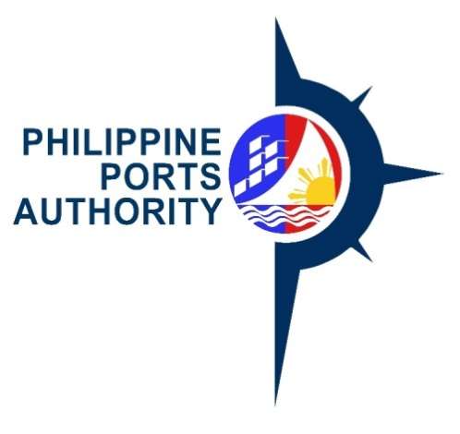

re-Invitation to Bid

FOR REPAIR OF R.C. WHARF, MOORING AND FENDERING SYSTEM AND BACK-UP AREA, PORT OF CORON, CORON, PALAWAN

The Philippine Ports Authority, Port Management Office of Palawan (PPA-PMO Palawan), through the Corporate Budget of the Authority for CY 2018, intends to apply the sum P27,321,297.40 being the Approved budget for the Contract (ABC) to payments under the contract for the Repair of R.C. Wharf, Mooring and Fendering System and Back-Up Area, Port of Coron, Coron, Palawan (COP-PLW-02-2018). Bids received in excess of the ABC shall be automatically rejected at bid opening.
The Philippine Ports Authority – PMO Palawan now invites bids of A.) General Expenses B.) R.C. Wharf C.) Mooring and Fendering System D.) Back-Up Area. Completion of the Works is required in 240 calendar days. Bidders should have completed a contract similar to the Project. The description of an eligible bidder is contained in the Bidding Documents, particularly, in Section II, Instructions to Bidders.
Bidding will be conducted through open competitive bidding procedures using non-discretionary “pass/fail” criterion as specified as in the 2016 Revised Implementing Rules and Regulations (IRR) of Republic Act 9184 (R.A. 9184), otherwise known as the “Government Procurement Reform Act.”
Bidding is restricted to Filipino citizens/sole proprietorships, cooperatives, and partnerships or organizations with at least seventy-five percent (75%) interest or outstanding capital stock belonging to citizens of the Philippines.
Interested bidders may obtain further information from the Philippine Ports Authority PMO-Palawan Bids and Awards Committee for the Procurement of Goods and Consultancy Services and for Engineering Projects (PMO-PALAWAN-BAC) and inspect the Bidding Documents at the address given below from 8:00 A.M. to 5:00 P.M., Monday to Friday.
A complete set of Bidding Documents may be acquired by interested Bidders on 04 June 2018 from the address below and upon payment of the applicable fee for the Bidding Documents, pursuant to the latest Guidelines issued by the GPPB, in the amount of TWENTY-FIVE THOUSAND PESOS (P25,000.00).
It may also be downloaded free of charge from the website of the Philippine Government Electronics Procurement System (PhilGEPS) and at the website of the Philippine Ports Authority, provided the bidders shall pay the applicable fee for the Bidding Documents not later than the submission of their bids.
The Philippine Ports Authority PMO-Palawan’s Bids and Awards Committee for Engineering Projects will hold a Pre-Bid Conference on 13 June 2018, 1:00 P.M. at Conference Room, 2nd Floor, PPA Administrative Building, Port Area, Puerto Princesa City, which shall be open to all prospective bidders.
Bids must be duly received by the BAC Secretariat at the address below on or before 8:30 A.M. of 26 June 2018. All bids must be accompanied by a bid security in any of the acceptable forms and in the amount stated in the bidding documents.

Bid Opening shall be on 26 June 2018, 9:00 A.M. at Conference Room, 2nd Floor, PPA PMO-Palawan Administrative Building, Port Area, Puerto Princesa City. Bids will be opened in the presence of the bidder’s representative who choose to attend. Late bids shall not be accepted.

*Required PCAB Registration: At least Medium A – Ports, Harbor & Offshore Engineering.
The PPA, PMO Palawan reserves the right to reject any and all bids, declare a failure of bidding, or not award the contract at any time prior to contract award in accordance with Section 41 of RA 9184 and its IRR, without thereby incurring any liability to the affected bidder or bidders.

For further information, please refer to:

BAC Secretariat
Philippine Ports Authority PMO-Palawan
Second Floor PPA Administrative Building,
Port Area, Puerto Princesa city

Tel. No. (048) 433-0356
Fax No. (048) 434-4881

Email Address : pmopalawanbac@gmail.com

(SGD) ELIZALDE M. ULSON
Chairperson
PMO-PALAWAN-BAC

