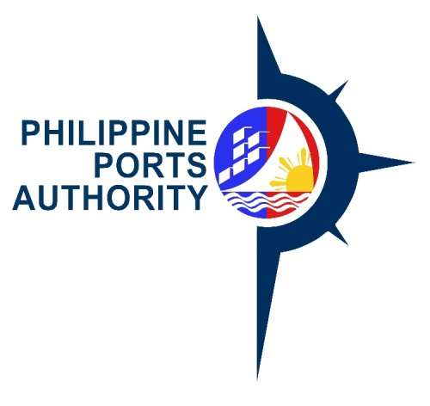

Invitation to Bid
for procurement of janitorial services OF PHILIPPINE PORTS AUTHORITY, PORT MANAGEMENT OFFICE OF PALAWAN FOR THE PERIOD JULY 1 – DECEMBER 31, 2018

- The Philippine Ports Authority, Port Management Office of Palawan ( PPA-PMO Palawan), through its CY 2018 Corporate Funds intends to apply the sum of One Milion Seven Hundred Forty-Five Thousand Twenty Five Pesos & 60/100 ( P 1,745,025.60 ) being the Approved Budget for the Contract (ABC) to payments under the contract for Procurement of Janitorial Services of Philippine Ports Authority, Port Management Office of Palawan for the period July 1 – December 31, 2018. Bids received in excess of the ABC shall be automatically rejected at bid opening.
- The PPA-PMO Palawan now invites bids for provision of janitorial services as described below. Delivery of the Goods is required at the time specified in Section VI, Schedule of Requirements. Bidders should have completed, within the last two (2) years from the date of submission and receipt of bids, a contract similar to the Project. The description of an eligible bidder is contained in the Bidding Documents, particularly, in Section II. Instructions to Bidders.

Name of  Project | Procurement of Janitorial Services of Philippine Ports Authority, Port Management Office of Palawan
Location | PMO Palawan ( all in the province of Palawan)  1. Baseport, Puerto Princesa City  2.TMO Brooke’s Point, Brooke’s Point, Palawan  3. TMO Cuyo, Cuyo, Palawan  4. TMO Coron, Coron, Palawan  5. TMO Culion, Culion, Palawan  6. TMO El Nido, El Nido, Palawan
Brief  Description | Involves the provision of janitorial services, materials, supplies and equipment
Contract  Duration | July 1 – December 31, 2018

- Bidding will be conducted through open competitive bidding procedures using a non-discretionary “pass/fail” criterion as specified in the 2016 Revised Implementing Rules and Regulations (IRR) of Republic Act (RA) 9184, otherwise known as the “Government Procurement Reform Act”.
Bidding is restricted to Filipino citizens/sole proprietorship, partnerships, or organizations with at least sixty percent (60%) interest or outstanding capital stock belonging to citizens of the Philippines, and to citizens or organizations of a country the laws or regulations of which grant similar rights or privileges to Filipino citizens, pursuant to RA 5183.

- Interested bidders may obtain further information from PPA-PMO Palawan and inspect the Bidding Documents at the address given below during office hours from 8:00 A.M. To 5:00 P.M.

The Schedule of Activities is as follows :

Activities | Date | Time
Issuance of Bid Documents | May 18- June 6, 2018 | 8:00 AM - 5:00PM
Pre-Bid Conference | May 25, 2018 | 9:00 A.M.
Submission of Bids | June 6, 2018 | 2:00 PM
Opening of Bids | June 6, 2018 | 3:00 PM

- A complete set of Bidding Documents may be acquired by interested Bidders on the dates specified above from the address below and upon payment of a non-refundable fee for the Bidding Documents, pursuant to the latest Guidelines issued by the GPPB, in the amount of Five thousand Pesos ( Php 5,000.00) inclusive of VAT.
It may also be downloaded free of charge from the website of the Philippine Government Electronic Procurement System (PhilGEPS) and the website of the Philippine Ports Authority, provided that Bidders shall pay the applicable fee for the Bidding Documents not later than the submission of their bids.

- The PPA-PMO Palawan will hold a Pre-Bid Conference on May 25, 2018 at 9:00 A.M. At the address given below, which shall be open only to all interested parties who have purchased the bidding documents.

- Bids must be duly received by the BAC Secretariat at the address below on or before June 6, 2018 at 2:00 PM.. All Bids must be accompanied by a bid security in any of the acceptable forms and in the amount stated in ITB Clause 18.
Bid opening shall be on June 6, 2018 at 3:00 PM Bids will be opened in the presence of the bidders’ representatives who choose to attend at the address below. Late bids shall not be accepted.

- The PPA, PMO Palawan reserves the right to reject any and all bids, declare a failure of bidding, or not award the contract at any time prior to contract award in accordance with Section 41 of RA 9184 and its IRR, without thereby incurring any liability to the affected bidder or bidders.

- For further information, please refer to:
Mrs. Aileen R. Uy
Head Secretariat
PMO-Palawan-BAC
Port Area, Puerto Princesa city
Telephone nos. (048) 434-5321
Email Address : bacgoods_ppc@yahoo.com

(SGD) ELIZALDE M. ULSON
PMO-PALAWAN-BAC Chairperson

PORT MANAGEMENT OFFICE – PALAWAN
PPA Administrative Building, Port Area
Port Area, Bgy. Bagong Pag-asa, Puerto Princesa City, Palawan
Telefax. Nos. (048) 434-5626, Email address: pmopalawan@ppa.com.ph

