DATA CENTER ACCESS FORM
Declaration and Data Privacy Consent: The information I have given is true, correct, and complete. By submitting this form, I authorize the Philippine Ports Authority to collect, use, process and retain my personal data in accordance with the PPA’s Privacy Statement and for purposes specified in this form.

 |  |  | INFORMATION |  |  |  | File Copy
NAME (Last name, First Name, Middle Name) |  |  |  |  |  |  |  |  | DATE
TIME IN |  | COMPANY |  |  |  |  |  |  | CONTACT NO.
TIME OUT |  | COMPANY ADDRESS |  |  |  |  |  |  | E-MAIL

PURPOSE

TYPE OF DATA ACCESS
□ General Access | □  Limited Access |  |  |  | □  Escorted Access

SUMMARY OF ACTIVITY

REMARKS

AUTHORIZATION
REQUESTED BY:  SIGNATURE OVER PRINTED NAME |  |  |  |  |  | APPROVED BY:  ICTD AUTHORIZED SIGNATURE |  | DATE

Important Reminder:
The information contained herein should be kept confidential and should be used solely by the employee whose name appears above. Should you fail to comply or should the security of your login credentials be compromised, your account will be locked out until such time that security is restored.
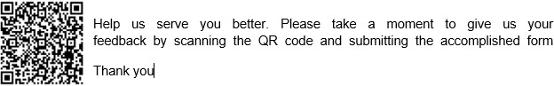
GENERAL INSTRUCTIONS:
- Indicate the name of person requesting for access in the data center.
- Indicate the date of request.
- Fill in the time in the data center.
- Fill in the name of company of the person who requested for access in the data center.
- Provide the contact number of the person who will access the data center
- Provide the company address and email address.
- Provide the purpose, why there is a need to access the data center.
- Put a check on type of data access.
- Provide the summary of activity.
- Provide remarks.
- Indicate name, date and affix signature of the person who requested and approved access to data center.

