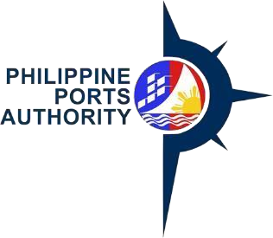
WEBSITE POSTING REQUEST FORM
Declaration and Data Privacy Consent: The information I have given is true, correct, and complete. By submitting this form, I authorize the Philippine Ports Authority to collect, use, process and retain my personal data in accordance with the PPA’s Privacy Statement and for purposes specified in this form.

INFORMATION |  |  | File Copy
NAME: (Lastname, First name, Middle Name)
OFFICE/DEPARTMENT: | DATE OF POSTING: |  | DURATION OF POSTING:
PURPOSE:
CONTENT:
ATTACHMENT:
REMARKS:
AUTHORIZATION
REQUESTED BY: |  | APPROVED BY:
SIGNATURE OVER PRINTED NAME |  | SIGNATURE OVER PRINTED NAME DATE

Important Reminder:
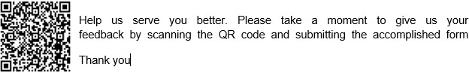
The information contained herein should be kept confidential and should be used solely by the employee whose name appears above. Should you fail to comply or should the security of your login credentials be compromised, your account will be locked out until such time that security is restored.

GENERAL INSTRUCTIONS:
- Provide name of person requesting for website posting
- Provide date of request
- Provide name of Office/Department
- Provide date of posting and duration
- State the purpose of posting at the PPA website
- Provide the content to be posted at the PPA website
- Provide the attachment and Remarks
- Fill in the name of person requesting for website posting and affix signature
- Fill in the name of person approving the request and affix signature and date

