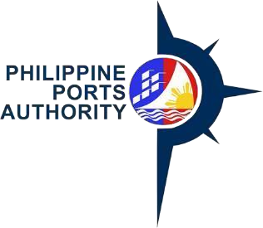

PORT CODE TEMPLATE

Declaration and Data Privacy Consent: The information I have given is true, correct, and complete. By Submitting this form, I authorize the Philippine Ports Authority to collect, use, process and retain my personal data in accordance with the PPA's Privacy Statement and for purposes specified in this form.

Port Code | Port Name | Address | Port Category | Port Type | Local Region | Manned | Office Code

Requested by: Approved by:

Signature over Printed Name |  | Date/Time |  |  |  | Signature over Printed Name |  | Date/Time

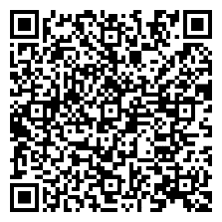
Help us serve you better. Please take a moment to give us your feedback by scanning the QR code and submitting the accomplished form. Thank you.

GENERAL INSTRUCTIONS (GI)

Port Name Exact name of the Port
Address Where the port is located

Port Category any of the following
GP Government Port
NP Non-Registered Private Port
RP Registered Private Port

Region What region it belongs

Manned any of the following
Y yes
N no

Port Type any of the following
B Base Port
F Foreign Port
O Other Government Port
P Private Port
S Special Port
T Terminal Port

